**Street Fighter 6**

Classic VS Modern Controls: Will Modern Controls eventually take over Classic Controls? Is the “Salt” justified?

**Mohamad Nabil Oueida, Shantanu Gupta, Ajith Krishnan Muralidharan**

# EXECUTIVE SUMMARY

In this dynamic world of the Fighting Games genre, Street Fighter 6 introduced the Modern Control Scheme to make new players feel more welcome to the game. This created certain issues in the Fighting Game Community which resulted in players complaining about the Modern Control Scheme due to some Players feeling like it is unfair for Modern Players to perform combos and special moves with easy input compared to their hard and complex inputs. Classic Controls were highly preferred by seasoned players and the Modern Control Scheme was primarily used by newcomers to be able to perform special combos and almost all the moves with rather simplifying inputs. In our research we focus on comparing the Win Rates of Street Fighter 6 characters and their Win Rate performances in respect to Modern Control Scheme vs Classic Control Scheme over the months of January, February and March. We have found that Modern Controls tend to dominate early Ranks, but when we reach Gold Rank the positions tend to switch and now Classic Controls are on top. This shows that Modern Controls are doing the job they were designed for which is to attract and get newcomers and casuals to start playing the game and taking it seriously in rank. We also found that Modern Controls are having better win rates across the month and that could potentially show that they are learning the fundamentals of the game better and are able to better compete with their better suited counterparts which are Classic Control Players. Thanks to this research we were able to basically see that Modern Controls will never really take over Classic Controls, but that a balance will be achieved with time as they learn the game. People who were complaining about Modern Controls are most likely Players in earlier Ranks since Modern Players are much more prevalent. This shows that the negative comments could be stemming from Classic Players who are not actually that advanced at the game, and these are also probably players that attribute being good at Street Fighter 6 to being able to pull off special moves with complicated inputs which Modern Players can do with a single button. The win rates at higher ranks are dominated by Classic which really shows that they are going nowhere and that Modern Controls Schemes are still a learning process for their Players. Players have to be able to compete within the proper metagame of Street Fighter 6 (footsies, neutral etc…) to be actual Good Players, not just rely on special inputs which explains the switch in dominance to Classic Controls in higher ranks.

# INTRODUCTION

In this research paper we are looking at the latest game from the Street Fighter Franchise by CAPCOM, Street Fighter 6. This game was released on June 2, 2023 and was the first traditional game to add a Modern Control Scheme for newcomers to the series to be able to get into the game quickly. Some old fans did not appreciate this introduction and a lot of complaints have been made by players who play Classic Controls. To understand more about why that is the case, we need to understand this genre a bit more.

Fighting games have been around for a long time in the gaming world ever since the first ever fighting game Heavyweight Champ in 1976 by Sega Corporation which did not even use traditional control schemes. Warriors developed by Atari in 1979 was an arcade game that featured the somewhat traditional control scheme with a joystick and a single button. Street Fighter by CAPCOM was released in 1987 as an arcade game with a similar control scheme although Street Fighter did something different by adding special hidden moves that require specific inputs to perform specific moves in such fighting games. Street Fighter was the very first game to add inputs as mechanics and the evolution of the control scheme increased. In the 80s fighting games dominated the arcade scene but as the genre grew more technical and complex with its controls, it became more brutal for newcomers coming to the scene who lacked any legacy skill or knowledge of how to play the genre or perform these hard controls. Due to this, newcomers and basically the casual players/scene got shut out, making the fighting game genre attractive to more of a niche community/fandom. The growing inaccessibility of the genre to newcomers/casuals due to its complexity was bringing an end to the arcade dominance this genre had.

Fighting games made it to console with the development of better controllers and had a rise due to the increase in competitive video gaming or what we now call Esports, but still it was mainly fans of the series or people who were interested in the genre, not casuals. With Smash Bros Brawl coming and changing the scenery with its modern controls that are easy to grasp but hard to master, a fighting game was finally attractive to a casual gamer.

Coming now to the 2020s, with the development of better internet connectivity and Rollback Netcode, fighting games were here to stay but still were mainly accessed by fans and people with a legacy of playing the genre. Street Fighter 6 with its new release added Modern Controls for players to use. These controls follow the same style of the Smash Control Scheme and make it very easy and accessible for players to perform special moves such as ODs(Overdrives) as well as Super Arts that require a pretty precise set of inputs when performed on a Classic Control Scheme. This new addition of the Modern Control scheme made it super easy for newcomers and casual gamers to pick up Street Fighter 6 and be able to play the game right away without much need of practice or understanding of the inputs system as much as Classic. Some old fans of the franchise criticized this development and some even outright call this control scheme broken and a sort of cheat for new players or casuals who do not have to go through the effort or training to perform ODs and Super Arts as they did. This “Salt” seems to stem because players using Classic Controls seem to be losing, or just feel it is unfair to them as they have to input complex controls that took time to learn which makes them think they are good at the game while a casual gamer can just come in and do the same moves with the ease of Modern Controls.

Due to the controversial topic that the Modern Control Scheme is in the Street Fighter 6 Community, we have decided to study Fighting Stats provided by Capcom to see if Modern Control Scheme Players are overtaking Classic Control Players, and if the Salt for it is justified.

# DATA SOURCES

For this game data analysis study, we are using data provided by Capcom via Buckler’s Boot Camp, a website that is updated on the second Thursday of each month.

From this website we are gathering the Fighting Stats for all fighters across each rank for the months of January, February and March of 2024. Each month will have data representing the Win Rates of each Character using different Control Schemes against every character and their respective Control Scheme. We plan on using this data to compare Control Schemes directly, look at their win rates across the months, across ranks, and across characters. We would also like to see if some characters perhaps do better in Modern compared to Classic and perhaps if there are trends that we can find.

The data we collected from the website had issues where the values did not round up to 1, as each Win by a character contributes a Loss to the other character. We were able to observe this during our data visualization when comparing respective match ups. Because of that, we have imputed the data and normalized it to give us a proper distribution of win rates that would add up to 1 when we combine both win rates for a match up.

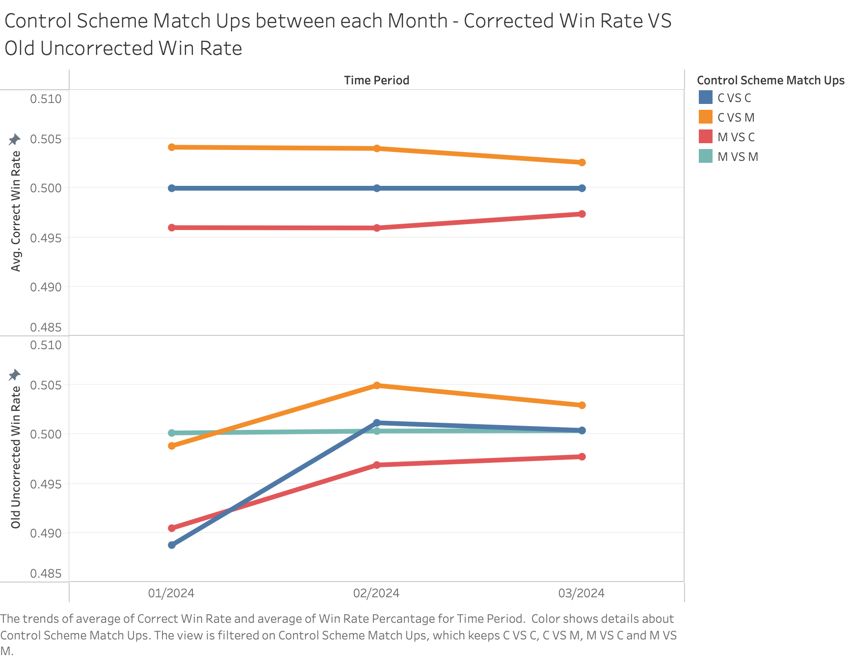

**Figure 1: Control Scheme Matchups between each Month for Corrected Win Rate vs Uncorrected Win Rate**

As we can see here, the Uncorrected Win Rate ends up with a weird visualization for C VS C and M VS M. Since these are mirror control scheme match ups across all ranks and time, each Win should be balanced by a loss (For each match up) hence the win rate 0.5 because each time a class/modern wins a mirror control scheme match, the other classic/modern player will lose so it supposed to show 0.5 win rate. Because of this visualization we were able to clearly see that there is an error in perhaps how the numbers were rounded and that is what triggered us to correct and normalize our data.

# METHODS & RESULTS

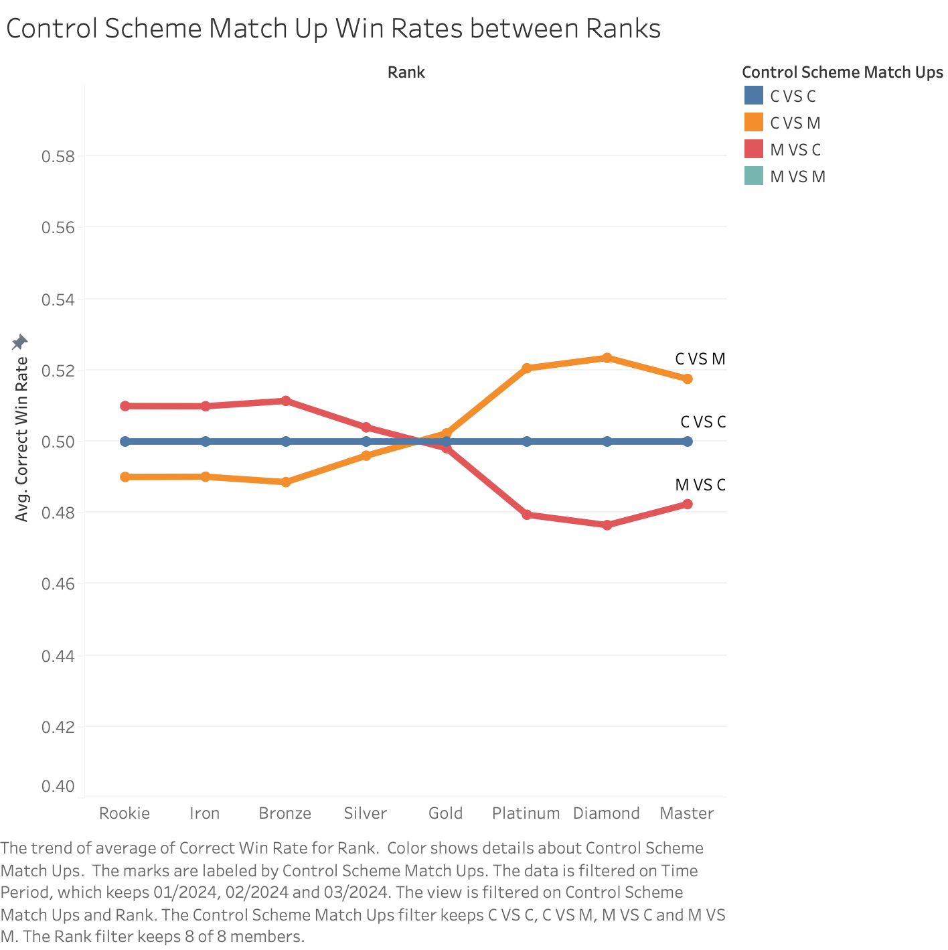

**Figure 2: Control Scheme Matchups showing the Win Rate per Rank**

Figure 2 contains the Win Rates of different Control Scheme match ups throughout the ranks in three months. Based on the visualization of the data, we can observe that Modern has a clear advantage over Classic Controls from the ranks of Rookie to Gold. But Modern takes a massive dip in Win Rates throughout Gold and after that, Classic starts rising in Win rates throughout the ranks of Gold to Master. To observe why that is, we decided to look at how the Win Rates vary in each month throughout the ranks and see what we can understand from it.

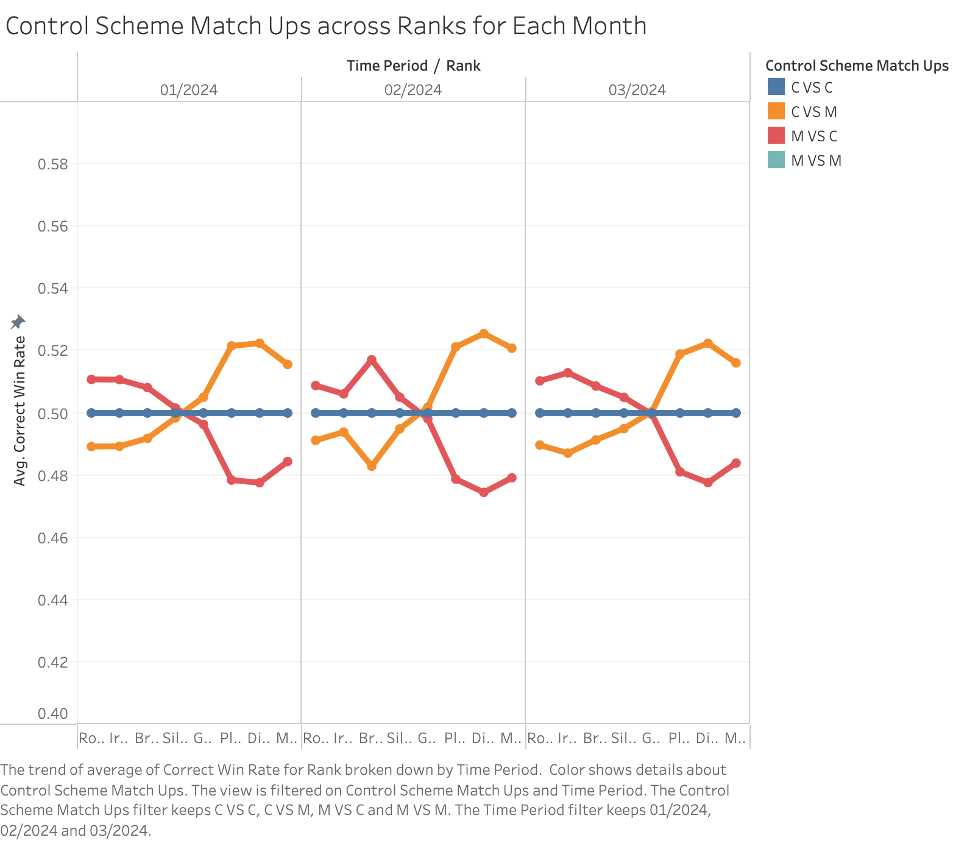

**Figure 3: Control Scheme Matchups showing the Win Rate per Rank for the month of January, February and March**

Figure 3 contains the Win Rates of the Control Scheme matchups in each month. In January the decline in win rates for Modern Controls began after the Silver rank. But in the following months of February and March, the decline in Win Rates began after the Gold rank which is the following rank after Silver. We notice a growth pattern in the Modern Controls, showing Modern Control players getting better at the game over time.

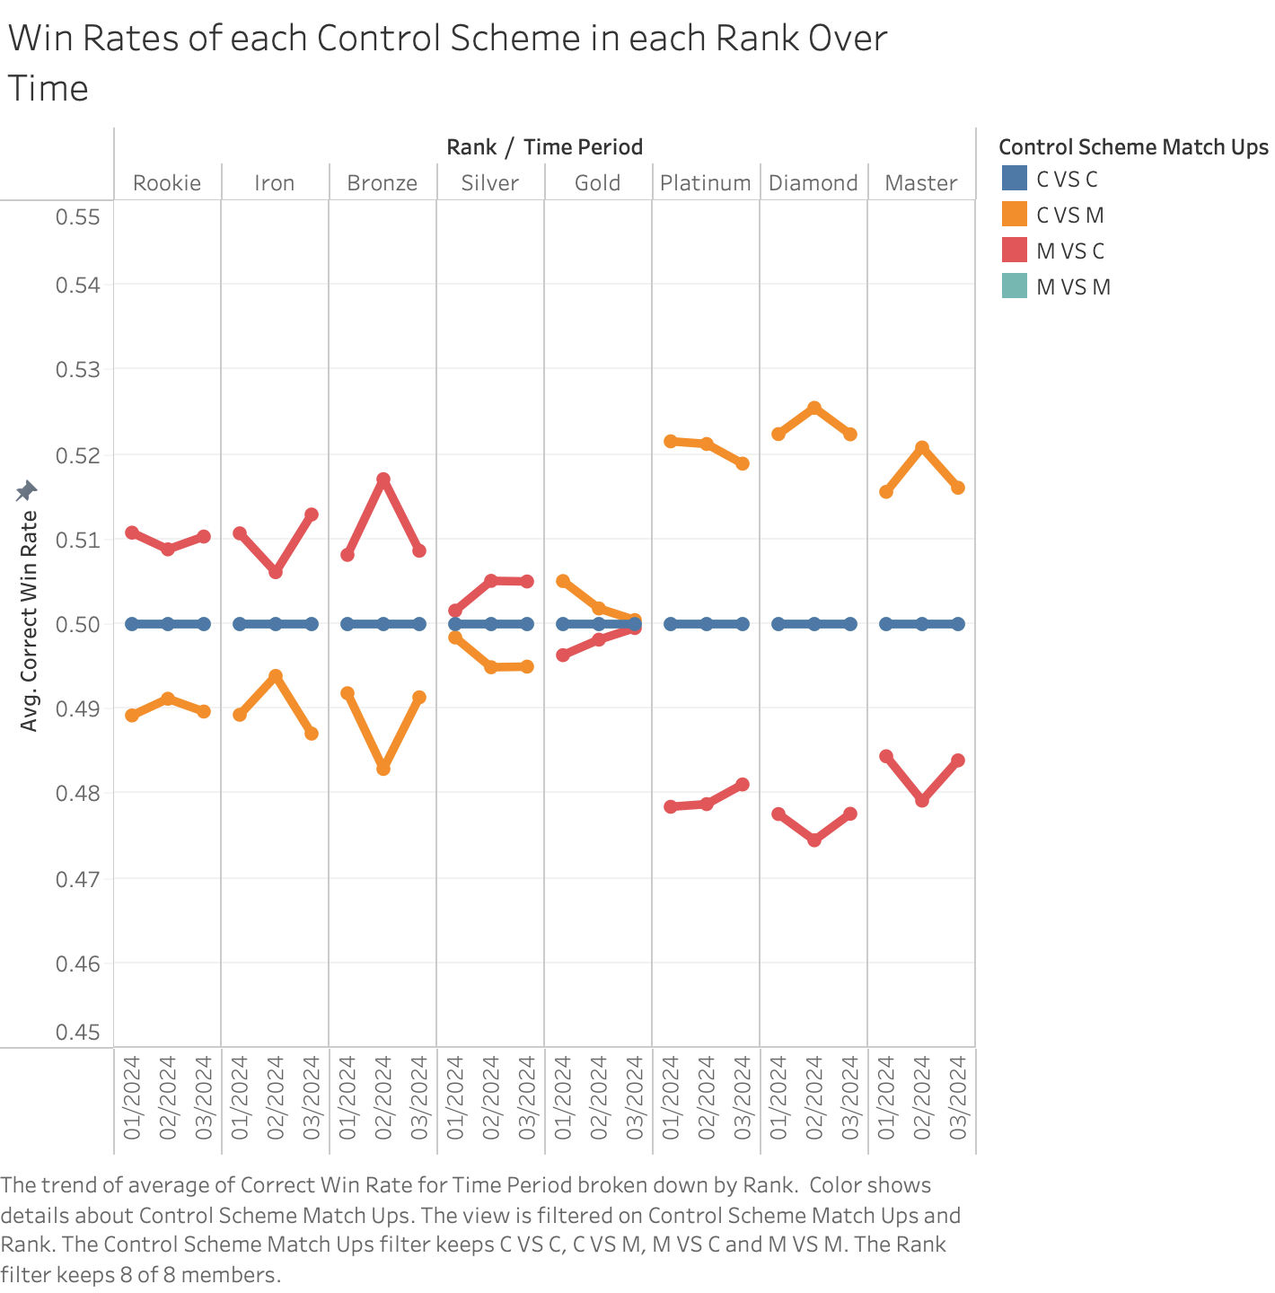

**Figure 4: Win Rate of all Control Schemes for each rank for the months of January, February and March**

In Figure 4, we get to see the win rates of each control scheme in each rank for 3 months. We are able to see how control schemes have improved or got worse in each rank for the period of time we selected. Because of the last graph where we saw an increase in win rates across the month for Modern Controls VS Classic Controls in Gold Rank, we have decided to visualize this table. Now when we look at the Gold Rank we can see that C VS M dips between each month which showcases a loss of win rate, and a gain in win rate from Modern Controls vs Classic Controls. Due to this finding we will visualize just the Gold Rank over the three months so we can better understand what is happening.

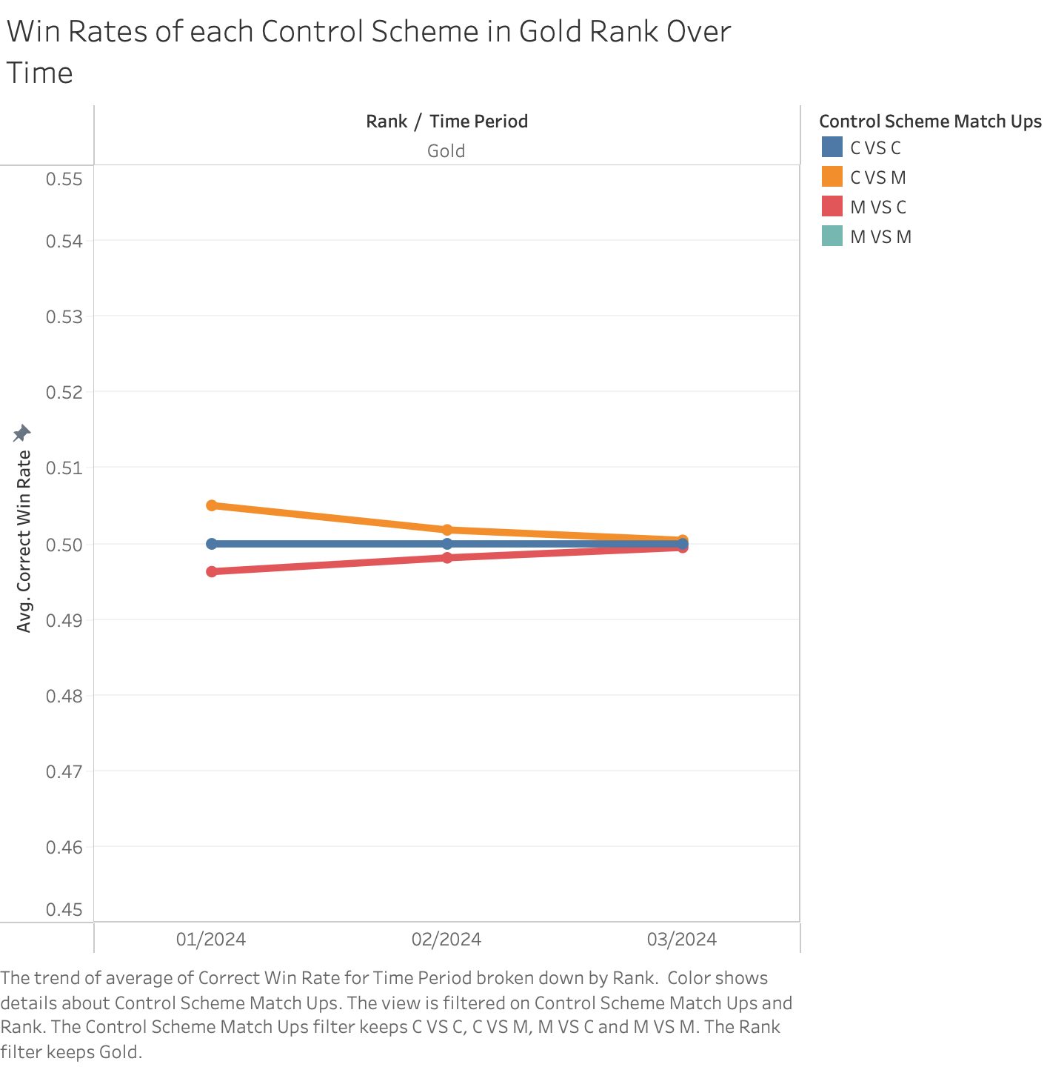

**Figure 5: Win Rate highlighting Control Schemes for the Gold Rank in January, February and March**

In Figure 5, we see that there is a balance that is being achieved between the Control Schemes in the Gold Rank. As we approach the month of March, we notice that the balance is very prominent. This also shows that players who play using the Modern Controls are getting better at the game over time. Players are adapting to the control scheme over time and the progress is very evident when we compare the data for the month of January, February and March.

Based on the figures above, we can see that Modern Controls tend to dominate early Ranks such as Rookie, iron, Bronze, Silver and a bit of Gold. After Gold we tend to see a switch in dominance with a move towards Classic Controls. We think Modern Controls are catered to newcomers and casual players so they can learn the game, perform special moves, supers, and combos easily which explains their dominance in the early ranks compared to Classic who have to do more complex inputs to achieve even a little bit of what Modern can do. Due to Modern having easier controls at early ranks, Modern Players have an easier winning and beating Classic Players who are still learning how to perform their moves while managing the neutral game of Street Fighter 6. After Gold, we see that Classic is taking over and gathering a higher win rate as the ranks go up. This shows that Classic Players that reach those ranks tend to beat Modern Control Players and that is due to them probably now knowing the controls well and having learned from their climb in rank. This dip for Modern might be due to their lack of efficient and damaging combos that Classic Players can now more easily achieve since they are more experienced. Also Modern Control Schemes do not give players the full set of special moves and tools as a way of Balancing, so probably in higher ranks players with Classic Control Schemes are able to utilize more tools at a higher level of play which is definitely the rise in Classic Win Rates as Rates go up.

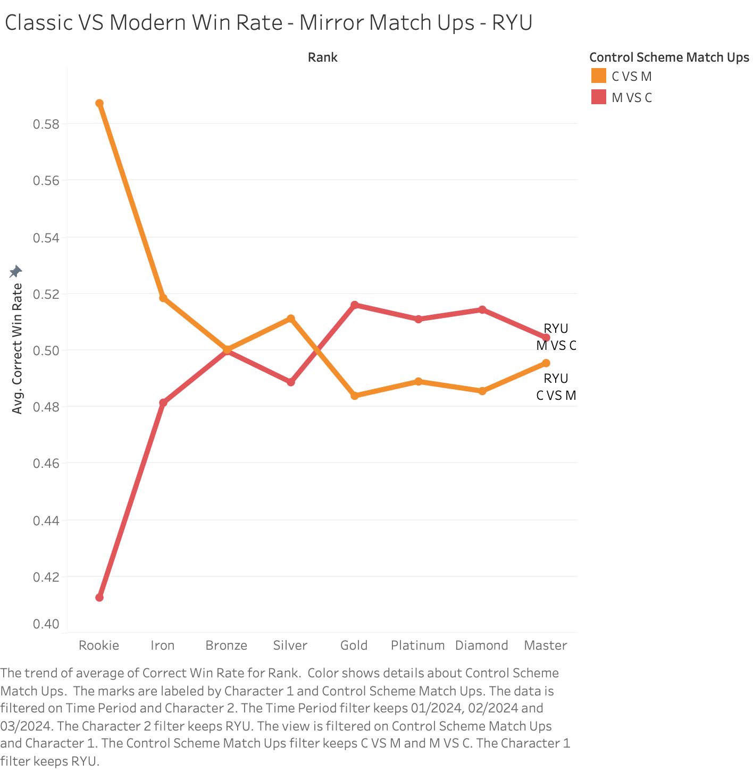

**Figure 6: Ryu Classic vs Ryu Modern Win Rate across all Ranks over time**

Figure 6 represents the data of Modern Controls vs Classic Controls for Ryu across all the Ranks across January, February and March. We observe that Win Rate for Classic Controls vs Modern Controls is extremely high in a lower rank (Rookie Rank) and that changes as the rank progresses. This Figure 6 focuses on the representation of Ryu Classic vs Ryu Modern which can be essentially termed as a mirror match up. We also observe that Ryu Modern vs Classic has a higher Win Rate compared to Ryu Classic vs Modern as the ranks progress towards Master. Ryu was the only character we have found to have a Mirror Match up where the Modern Controls have a higher win rate at higher ranks instead of lower ranks and vice versa for Classic. We wonder why Ryu could possibly be the only one to have achieved this when we were expecting the other shotos (Ken, Luke) to do so as well but in their cases Classic dominates later ranks. Is it because Ryu is the face of the franchise before Luke? And players who picked him up with Modern Controls stayed with him till the end and ended up beating Classic Controls?

We think Perhaps these players just fundamentally grew an understanding of the game and its neutral game and were able to efficiently use Ryu in Modern Classic.

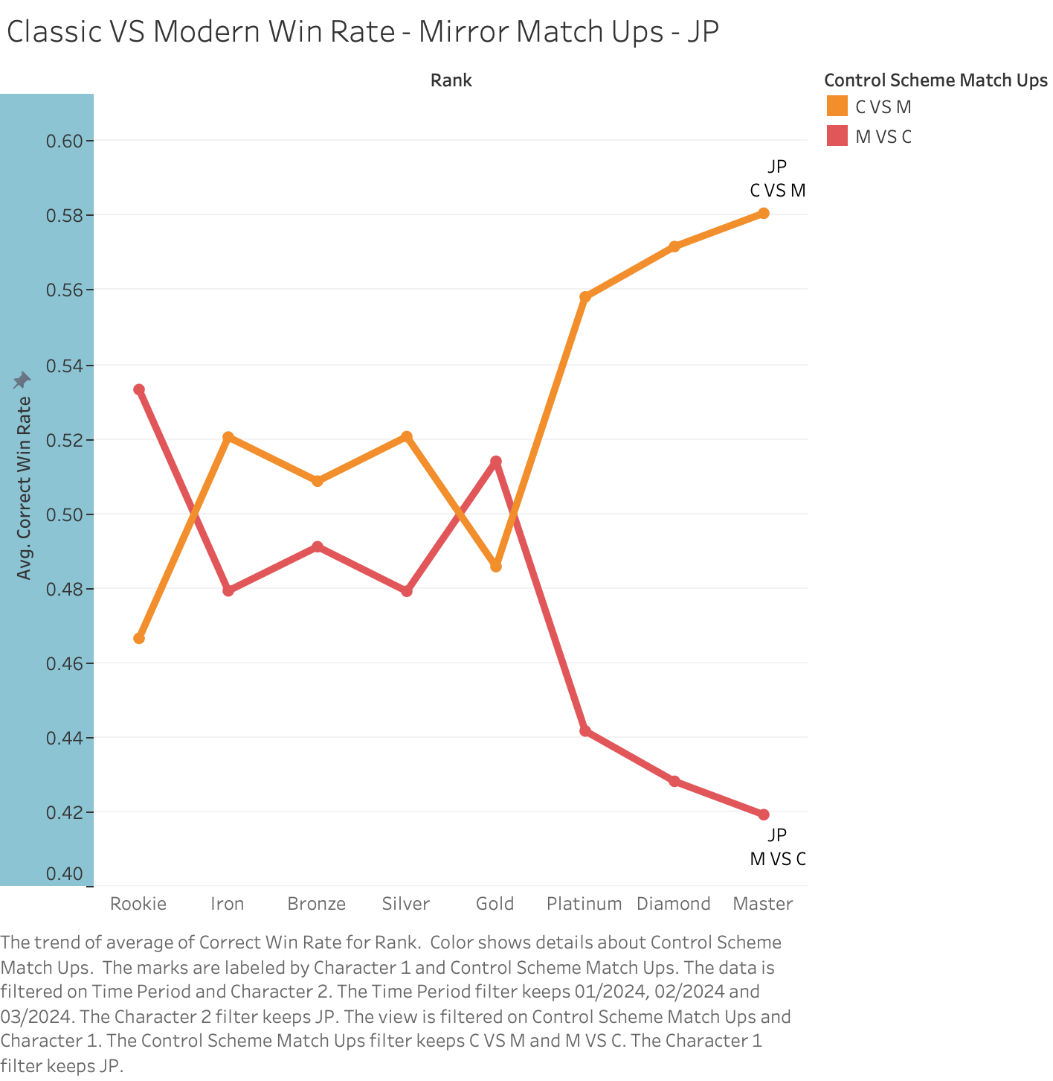

**Figure 7: JP Classic vs JP Modern Win Rate across all Ranks over time**

Figure 7 represents the matchup of Classic Control Scheme JP vs Modern Control Scheme JP. We observe that as the Ranks progress (after Gold Rank), there is a huge gap between JP Classic vs Modern and JP Modern vs Classic. People at higher ranks dominate the Classic JP control scheme. This is mainly due to how complex the character is and that players would need to really know the character in order to be able to dominate. Modern Control Scheme JP players are unable to create enough space between its opponent with their available tools which is why there might be a huge difference between the Win Rate of Modern vs Classic as the characters progress the ranks.

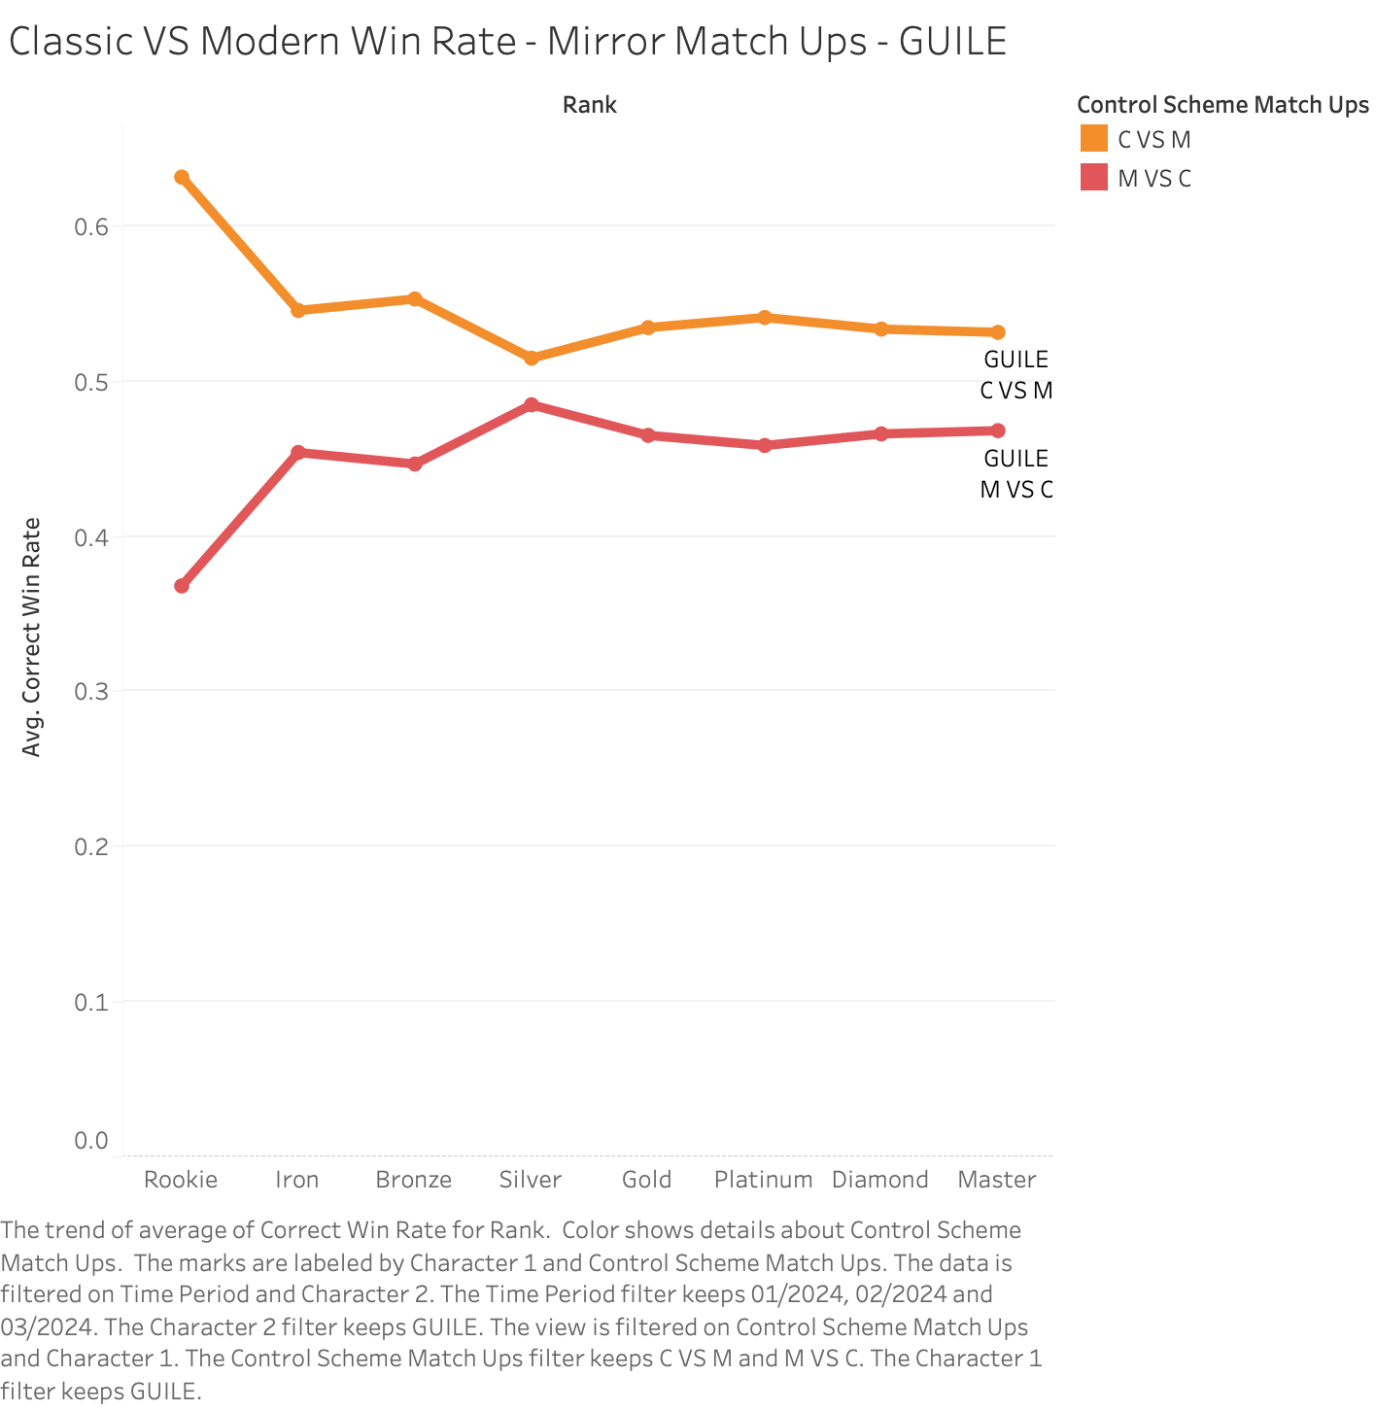

**Figure 8: Guile Classic vs Guile Modern Win Rate across all Ranks over time**

Figure 8 represents the Win Rate between Guile Classic vs Modern and Guile Modern vs Classic. This representation is particularly interesting because Classic Guile has a higher win rate across all ranks compared to Modern Guile, so much so that they never intersect. There is no intersection between both the lines on the graph, which helps us make an assumption that Guile is most definitely a character that is perhaps better suited for Classic Controls. We think this might be the case due to him having charge attacks as his main special moves. Charge attacks are a complex motion of holding back a direction for a few seconds and then inputting the opposite direction with the attack button to perform said special move. Modern Control Schemes do not offer much of a change for charge attacks as players must still charge by holding back a direction and do an input right after. Perhaps due to this Players who seek to play Guile would just rather go for Classic Controls as the main tools both Control Schemes offer almost have the same input so might as well go for the Control Scheme with more tools available for the Player. That could explain the sheer dominance Classic Guile has over Modern Guile.

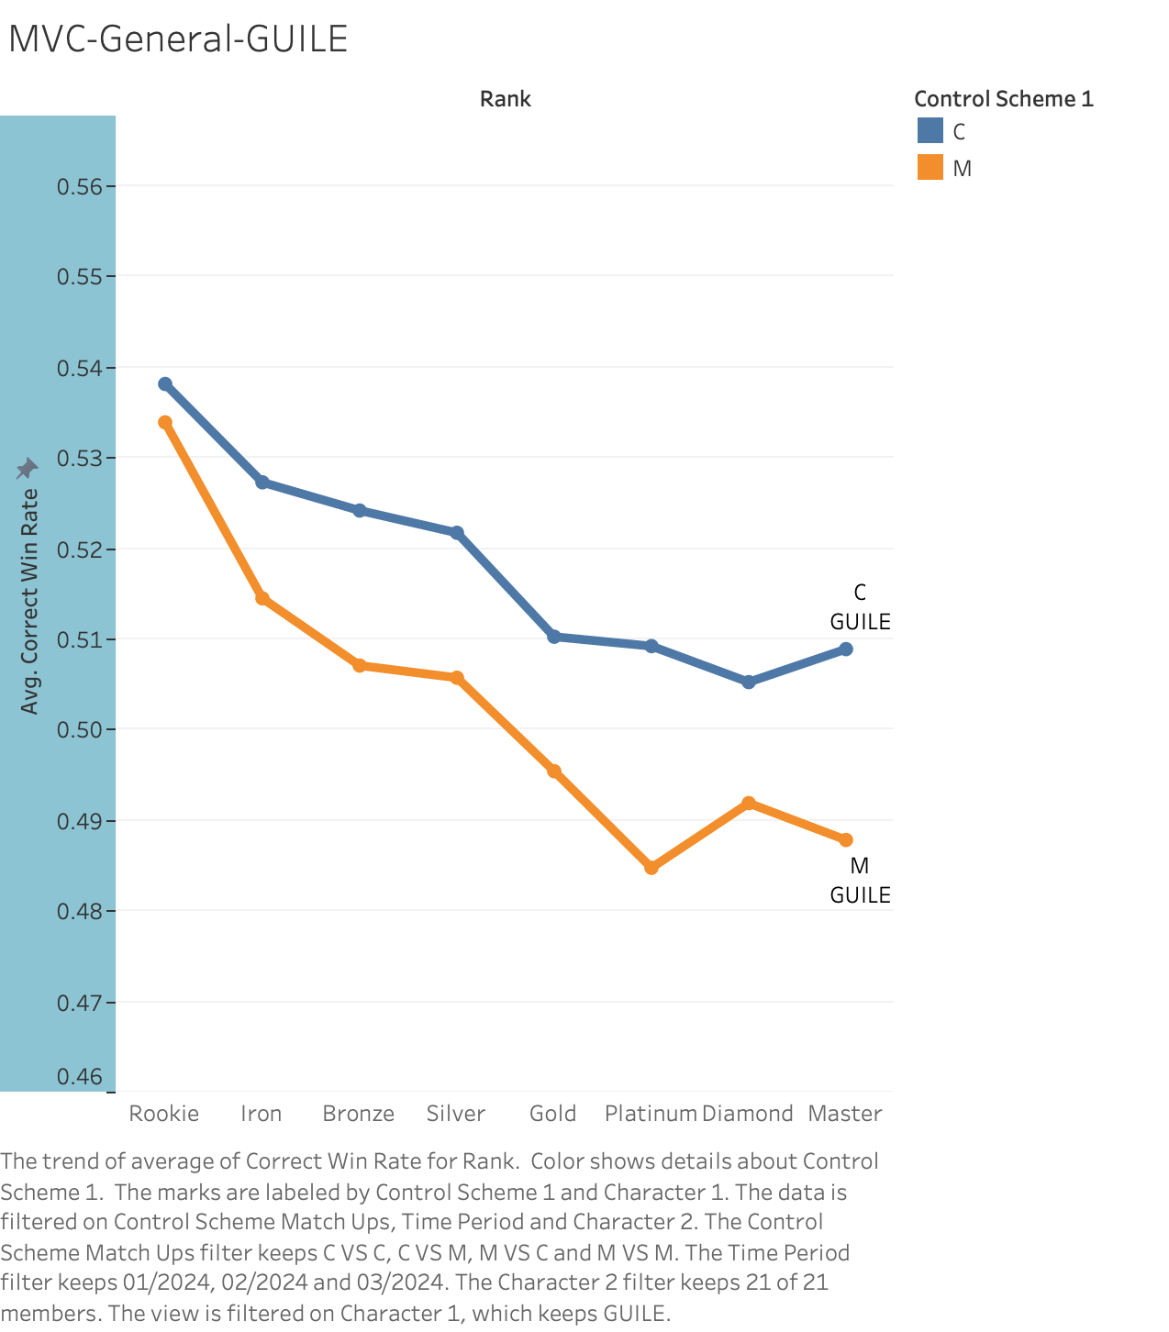

**Figure 9: Modern Controls vs Classic Controls Win Rate for Guile over all Ranks over Time**

Figure 9 represents the overall Modern Controls vs Classic Controls Win Rate for Guile. While we see a similar pattern to Figure 8, where both lines do not intersect with each other. Guile Classic has a significantly higher win rate compared to Guile Modern across all ranks which shows perhaps how much better utilized Guile is in Classic compared to Modern. Guile is one of the few characters that have charge moves and players playing the Modern Control Scheme have to kind of perform the same input so it not really that much of a shortcut and their is a damage debuff on top of that.I think because of Modern Guile’s special moves not being that different, and Modern having a damage debuff makes Classic Guile just an all around better choice for all Players who want to learn the character. Why use a Control Scheme that basically offers no real shortcut and a damage debuff.

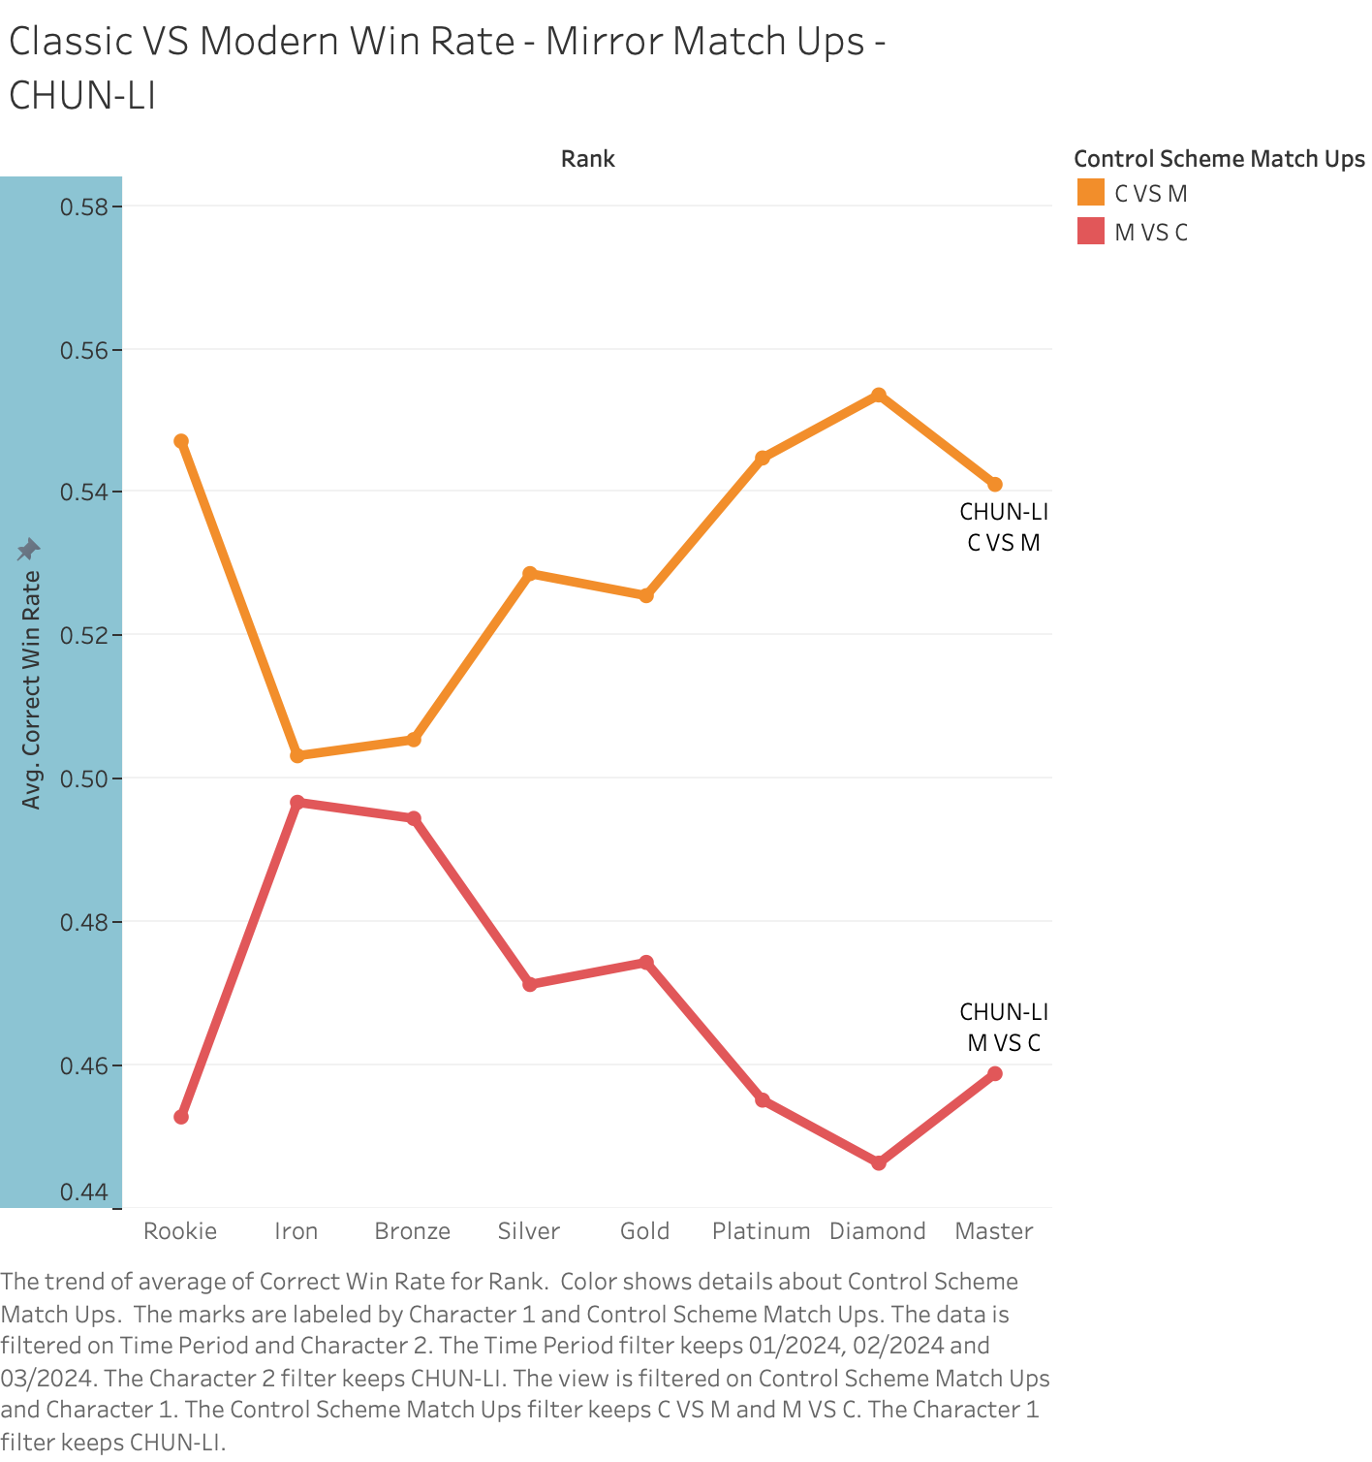

**Figure 10: Modern Controls vs Classic Controls Win Rate for Chun-Li over all Ranks over Time**

Figure 10 represents the Win Rates of Classic against Modern Control Chun-Li players throughout the ranks. Similar to the pattern we observed with Guile in the above chart, the Win Rates of Modern Control players never beat Classic Chun-Li players. Chun-Li who is also a charge character from the standpoint of Classic Control scheme.Even though Modern has a similar input to Classic, Charge Characters have had a specific play style that relates only to Classic Control players. This could be a reason as to why Modern never overtakes Classic in this case as Classic Players have a legacy of playing this character and understand how they move to have the edge, similar to Guile as well.A majority of the Modern Control players on the other hand are more focussed on the special moves and less on character types, and also even in the higher ranks the decline might be because of the case of some of the missing moves in the Modern Control Type that leads to them being not able to execute meta combos that give you the edge in the match.

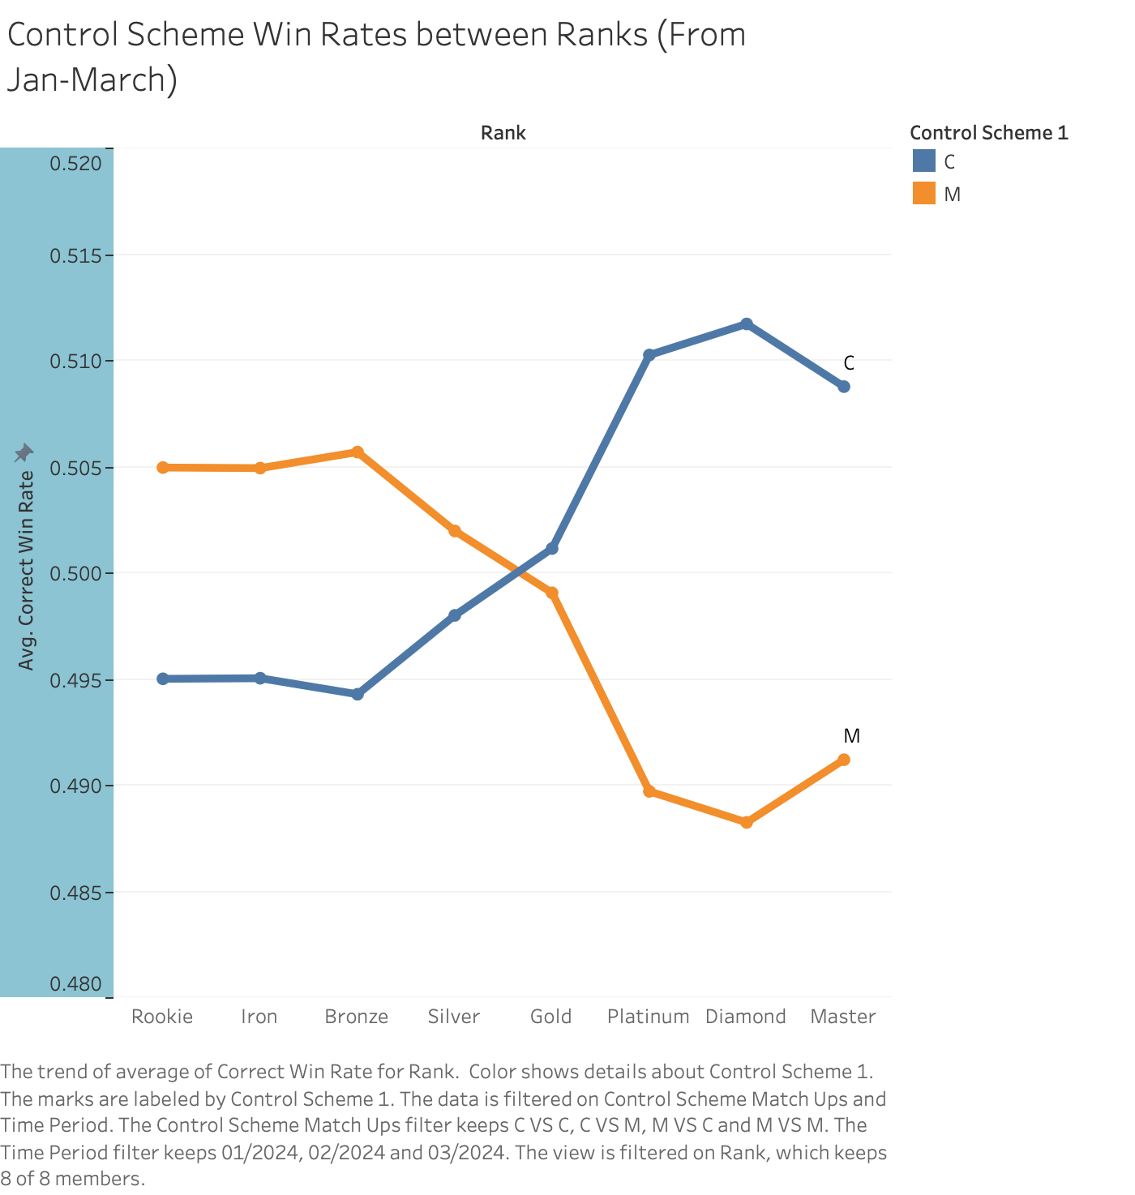

**Figure 11: Modern Controls vs Classic Controls Win Rate for All Characters over all Ranks over Time**

Figure 11 gives us a much better understanding of the Win Rate of Classic Control Scheme vs Modern Control Scheme. The Modern Control Scheme allows casual players and newcomers to perform special moves without having to learn the more complicated control scheme which is the Classic Control Scheme. The new Modern Control Scheme allows players to compete in the lower ranks while also feeling somewhat challenged by the Control Scheme. We observe that as the Rank progresses, the Win Rate for Modern Control Scheme starts to fall off and the Win Rates for Classic Control Scheme starts to increase, that is primarily because once you have reached that stage of “high skill plays”, you are also likely to encounter the more traditional players who have been playing fighting games and are very familiar with the traditional control scheme which is the Classic Control Scheme. Classic takes over the wins against Modern and as we progress further above the Ranks, this data becomes more prominent.

This would lead us to believe that the game is very well balanced in the sense, it is very welcoming to newcomers and casual players. Introducing the genre to new players via the Modern Control Scheme which makes players not have to memorize the more complex Classic Control Scheme. Modern Control Scheme players are able to play the game, perform supers and special combos while also progressing in the game. As they reach the higher ranks, those newcomers are met with the more traditional players of the Fighting game genre that only play the Classic Control Scheme. Classic Control Scheme is for players with experience and for players who want to be more creative with their moves, Modern Control Schemes is for players looking for simplicity and for newcomers looking for a way into the Fighting Games genre.

I believe we met our proposed research objective about 75% of the way. Yes, Modern Controls dominate early ranks and Classic higher Ranks.The loss of Modern Control at higher ranks is probably due to the lack of tools and damage debuff that Modern Players get, compared to Classic Players who have all options available and do more damage. Modern Controls give the chance for newcomers to truly compete and it is smart for Street Fighter 6 to be more accessible.

We believe that since we saw an increase in Win Rates from Modern Controls over the three months in Figure 1 that Modern Controls Players are learning the fundamentals of the game more and are using their tools more efficiently to better compete with Classic Controls. This leads to the factor that understanding the fundamentals of the game and its characters takes priority over control schemes that are just tools that help you to access it.

So basically, Modern Controls will not really overtake Classic but rather we think a balance might be achievable in the future where we don't see as much of a gap as Modern Players get better at just understanding the neutral game of Street Fighter 6. And basically due to how Modern Controls have been designed to make the game more accessible to newcomers and casuals, it has definitely done its job well and you can see that in the early rank win rates. But as rank goes up we can see that the experienced players start to take their rightful place and now Modern Players are on the losing side learning how to Play at a higher level. This showcases that the “Salt '' gathered by the community for this Modern Control Scheme is unwarranted and not justified since it is probably players at lower ranks who were complaining about Modern Players. Modern Controls don't make Players good at Street Fighter 6, it is the understanding of the Fundamentals of the game and High Level Play that makes a player good.

# FUTURE WORK

Our current data analysis does not involve character usage statistics with Control Schemes in Mind and does not give us the total number of people using Modern Control Scheme or Classic Control Scheme. Using the Character Usage Statistics we could have known the count of Modern players vs Classic players, whether the number of Modern Players are increasing which is something that can definitely help us better answer our question. We could also learn the percentage of Modern Players that play the game in Higher Rank i.e above Platinum and see whether they decline or rise over the course of time to see if Modern can really turn from a casual friendly Control Scheme to a competitive one. Our research helps understand our current topic well with very few limitations which limits our scope for future work.

# BIBLIOGRAPHY OR WORKS CITED AS APPROPRIATE (PER ACADEMIC CONDUCT GUIDELINES)

* Maximilian Dood: [Modern vs Classic Controls | Which is BETTER?](https://www.youtube.com/watch?v=XS1gxKH6ggQ)
* Buckler’s Boot Camp: [www.streetfighter.com/6/buckler/stats/dia](https://www.streetfighter.com/6/buckler/stats/dia)
* 10 ways Street Fighter changed games for ever: [www.redbull.com/us-en/street-fighter-10-ways](http://www.redbull.com/us-en/street-fighter-10-ways)
* The evolution of Fighting Games [medium.com/@lurlichs/the-evolution-of-fighting-game-controllers-peripherals-5b8f025b7687](https://medium.com/@lurlichs/the-evolution-of-fighting-game-controllers-peripherals-5b8f025b7687)
* Street Fighter 6 Best Control Scheme: Classic & Modern Differences Explained: [screenrant.com/street-fighter-6-classic-modern-controls-explained](https://screenrant.com/street-fighter-6-classic-modern-controls-explained)

Cleaned Data: [Street Fighter 6 Clean Results](https://docs.google.com/spreadsheets/d/1aPUXJu5WmYxddyAOOuEBCiPo-Ytsth1uhOsfVCt0FbI/edit?usp=sharing)